VISVESVARAYA TECHNOLOGICAL UNIVERSITY
Jnana Sangama, Belgaum-590018


Mini Project Report
on
“IoT-ENABLED SMART PILL BOTTLE FOR MEDICINE REORDERING”
Submitted in partial fulfillment of the requirements for the
First Semester of the Bachelor of Engineering Degree, towards the completion of the Mini Project under the Innovation & Design Thinking Laboratory,
Department of Basic Sciences.

by

SN | Name | USN/Roll number
01 | G ABHIRAM | N – 10
02 | G ABHISHEK | N – 11
03 | G NIVETHASREE | N - 12

Under the Guidance of
Dr. REBECCA SANDRA PAUL P
Asst. Professor, Dept. of ISE



CMR INSTITUTE OF TECHNOLOGY
#132, AECS LAYOUT, IT PARK ROAD, KUNDALAHALLI,
BANGALORE-560037

CMR INSTITUTE OF TECHNOLOGY
#132, AECS LAYOUT, IT PARK ROAD, KUNDALAHALLI,
BANGALORE-560037
DEPARTMENT OF BASIC SCIENCES

CERTIFICATE
This is to certify that the File Structures mini project entitled “IoT-ENABLED SMART PILL BOTTLE FOR MEDICINE REORDERING” has been successfully carried out by G Abhiram (N - 10), G Abhishek (N - 11), and G Nivethasree (N - 12), Bonafide students of CMR Institute of Technology.
The project is submitted in partial fulfillment of the requirements for the First Semester of the Bachelor of Engineering Degree, towards the completion of the Mini Project under the Innovation & Design Thinking Laboratory, Department of Basic Sciences.
It is further certified that all corrections and suggestions indicated during the Internal Assessment have been duly incorporated in the project report submitted to the departmental library. This File Structures mini project report has been reviewed and approved as it satisfies the academic requirements prescribed for the said degree.
----------------------- ----------------------
Signature of Guide Signature of HOD
Dr. REBECCA SANDRA PAUL P
Dr. Raveesha K H
Asst Professor, HoD,
Dept. of ISE, CMRIT Dept. of Physics, CMRIT
External Viva
Name of the examiners Signature with date
1.
2.
TABLE OF CONTENT

Title Page No

A Acknowledgement |  | i
Abstract |  | ii
List of Figures |  | iii
Chapter 1
INTRODUCTION ……………………………………………………………... |  | 1
1.1 Brief History ………………………………………………………………… |  | 1
1.2 Primary Goals ………………………………………………………………. |  | 1
Chapter 2
ABOUT THE PROJECT ……………………………………………………... 2
2.1 Description…………………………………………………………………… 2
2.2 Problem Statement ………………………………………………………….. 2
2.3 Objective of the Project …………………………………………………….. 2
2.4 Proposed Solution ………………………………………………………….. 2
2.5 Advantages of Proposed solution ………………………………………...... 2

Chapter 3
DESIGN …………………………………………………………………….. 3
3.1 Design Thinking process………………….. ………………………….. 3
3.2 Methodology………………………………………….. …………….... 3
3.3 Prototype Description………………………………………………………….4
3.3.1 Materials Used …………………………………………………………..…4-6
3.3.2 System Diagram ……………………………………………………………6

Chapter 4
IMPLEMENTATION………………………………………………. 7-10
4.1 Arduino Program (Embedded System Code)…………………………….... 7-8
4.2 Mobile Application Program (Android App Code)………………………….9-11

Chapter 5
RESULT AND ANALYSIS …………………………………………………….12
5.1 User Testing & Feedback…………………………………………………..... 12
5.2 Hardware Setup and Output Description…..…………………………..….......12-14

Chapter 6
CONCLUSION & FUTURE WORK………..…………………………………… 15
REFERENCES …………………………………………………………………. 15
Annexure……………………………………………………………………………16

ACKNOWLEDGEMENT

I sincerely express my gratitude to Dr. Sanjay Jain, Principal, CMR Institute of Technology, Bangalore, for providing a supportive academic environment.
I extend my thanks to Dr. Raveesha K H, HoD, Dept. of Physics, CMRIT for his valuable guidance and support.
I am especially grateful to my internal guide, Dr. REBECCA SANDRA PAUL P
, Asst Professor, Dept. of ISE, for her/his constant encouragement and guidance throughout this project.
I also thank all the faculty members, non-teaching staff, and others who contributed directly or indirectly to the successful completion of this work.

G Abhiram (N - 10)
G Abhishek (N - 11)
G Nivethasree (N - 12)

i
ABSTRACT

IoT-enabled smart pill bottle for medicine reordering project is designed to enhance medication management by accurately monitoring pill availability and communicating real-time status information to users through a mobile application. The primary objective of the system is to detect whether a pill bottle is full, partially filled, or empty, thereby supporting timely refilling and reducing the risk of missed medication. The system utilizes an ultrasonic sensor to measure the depth inside the pill bottle, which corresponds to the remaining quantity of medication. These measurements are processed by a microcontroller, which interprets the data to determine the bottle status. The processed information is then transmitted wirelessly via a Bluetooth module to a mobile application, enabling users to view pill availability instantly. The mobile interface provides clear status updates and alerts, improving usability and awareness. The implemented system demonstrates accurate depth detection, stable Bluetooth communication, and reliable data transfer to the application. The outcome of the project confirms that sensor-based monitoring combined with wireless communication can offer a simple, cost-effective, and efficient solution for medication tracking. This approach reduces manual checking, supports better adherence, and showcases the practical application of embedded systems and IoT concepts in smart healthcare solutions.

Keywords :
- IoT-enabled smart pill bottle
- Ultrasonic sensor
- Bluetooth communication
- Medication tracking
- Mobile application
- IoT healthcare

ii
LIST OF FIGURES

Figure No. | Title | Page No.
Fig -1 | Methodology …………………………………………………. | 3

Fig 2 | Ultrasonic Sensor……………………………………………. | 4

Fig -3 | Arduino Uno …………………………………………………. | 4

Fig 4 | Bluetooth Module …………………………………………. | 5

Fig -5 | Breadboard …………………………………………………. | 5

Fig 6 | Jumper Wires…………………………………………………. | 5

Fig -7 | Android Smartphone…………………………………………………………………. | 5

Fig 8 | System Diagram …………………………………………. | 6
Fig -9 | 2Hardware Setup and Output Description ………………………. | 12

Fig 10 | Mobile application…………………………………. | 13

iii
Chapter 1

1.INTRODUCTION

1.1 Brief History
Medication adherence is a critical factor in effective healthcare management, especially for elderly patients and individuals undergoing long-term treatment. Traditional methods of monitoring medicine availability rely on manual checking of pill bottles, which is often neglected or forgotten. This can lead to missed refills, skipped doses, and serious health complications.
With the advancement of Internet of Things (IoT) technologies, smart healthcare systems have emerged that enable automated monitoring and timely alerts. By integrating sensors, embedded controllers, and mobile applications, it is possible to continuously track medicine levels and assist users in managing their medication more effectively.

1.2 Primary Goal
This project focuses on the development of an IoT-Enabled Smart Pill Bottle for Medicine Reordering, which automatically monitors pill levels using sensors and notifies users through a mobile application. The system not only alerts the user when medicine stock is low but also provides a convenient medicine reordering option, making the solution practical, user-friendly, and reliable

-1-
Chapter 2

Problem Statement

2.1 Description

Manual tracking of medicine stock is inconvenient and error-prone. Patients often forget to monitor pill levels, leading to missed refills and potential health risks.

2.2 Challenge Statement

- To automatically monitor pill levels inside a medicine bottle
- To notify the user when the pill stock is low
- To provide a medicine reordering option through a mobile application

2.3 Objective :
Development of an IoT-Enabled Smart Pill Bottle for Medicine Reordering, which automatically monitors pill levels using sensors and notifies users through a mobile application.
2.4 Proposed Solution
The proposed solution uses an ultrasonic sensor to detect the pill level inside the bottle. An Arduino microcontroller processes the sensor data and determines the pill status. The status is transmitted wirelessly to a mobile application via a Bluetooth module. The application displays the pill status and provides a reorder medicine button for quick refilling.

2.5 Advantages of the Proposed Solution
- Automatic pill level monitoring.
- Reduces human error and manual checking.
- Easy medicine reordering.
- Cost-effective and user-friendly.
- Useful for elderly and long-term patients.

-2-
Chapter 3

3.1 Design Thinking Process

Empathize:
Interactions with patients, elderly individuals, and caretakers revealed that most users forget to monitor pill stock until medicines are completely exhausted.
Define:
The main requirements identified were automatic pill level detection, real-time alerts, minimal user interaction, and an easy medicine reordering option.
Ideate:
Several ideas such as weight-based sensing, manual input apps, and camera-based monitoring were explored. The final solution chosen was an ultrasonic sensor-based pill level detection system integrated with a mobile app.
Prototype:
A working prototype was developed using an ultrasonic sensor, Arduino microcontroller, HC-05 Bluetooth module, and an Android mobile application.
Test:
The system was tested under different pill levels and successfully detected low-stock conditions with reliable notification delivery.

3.2 Methodology

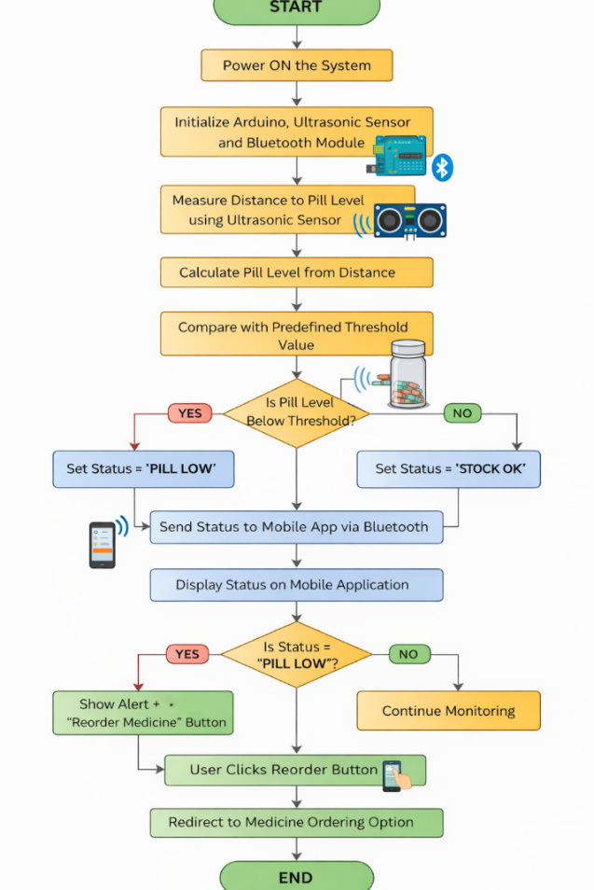
Fig-1

-3-
The flow chart describes the working methodology of the IoT-Enabled Smart Pill Bottle for Medicine Reordering. When the system is powered on, the Arduino initializes all connected components including the ultrasonic sensor and Bluetooth module. The ultrasonic sensor continuously measures the distance between the sensor and the pill surface inside the bottle. This distance value is used to estimate the pill level.
The Arduino compares the measured value with a predefined threshold. If the pill level is below the threshold, the system identifies a low-stock condition and sets the status as “PILL LOW”; otherwise, it sets the status as “STOCK OK”. The pill status is transmitted wirelessly to the mobile application via Bluetooth.
The mobile application displays the pill status to the user. When a low-stock condition is detected, the application shows an alert. Upon clicking the reorder button, the user is redirected to a medicine ordering platform, allowing quick and convenient refilling. The system then continues monitoring the pill level automatically.

3.3 Prototype Description

3.3.1 Materials Used

Ultrasonic Sensor:
The ultrasonic sensor is used to measure the distance between the sensor and the pill level inside the bottle. It works by transmitting ultrasonic sound waves and receiving the reflected echo. The measured distance is used to estimate the remaining pill quantity. This sensor is cost-effective, accurate, and suitable for non-contact measurement.
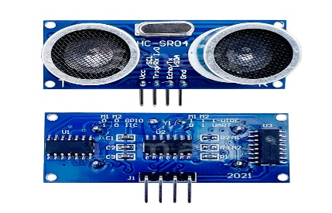
Fig-2
Arduino Uno:
Arduino Uno acts as the central processing unit of the system. It reads data from the ultrasonic sensor, performs threshold comparison, and determines whether the pill level is low or sufficient. Based on the logic, it sends the pill status to the mobile application through the Bluetooth module.

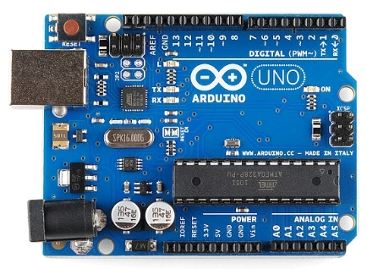
Fig-3
HC-05 Bluetooth Module:
The HC-05 Bluetooth module enables wireless communication between the Arduino and the Android mobile application. It transmits pill status messages such as “PILL LOW” or “STOCK OK” in real time, allowing the user to monitor pill levels through the app.
-4-
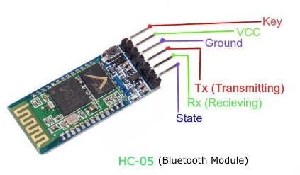
Fig-4
Breadboard:
The breadboard is used to assemble and test the circuit without soldering. It provides a temporary and reusable platform to connect the Arduino, ultrasonic sensor, Bluetooth module, and other components. The breadboard simplifies prototyping and debugging during development.
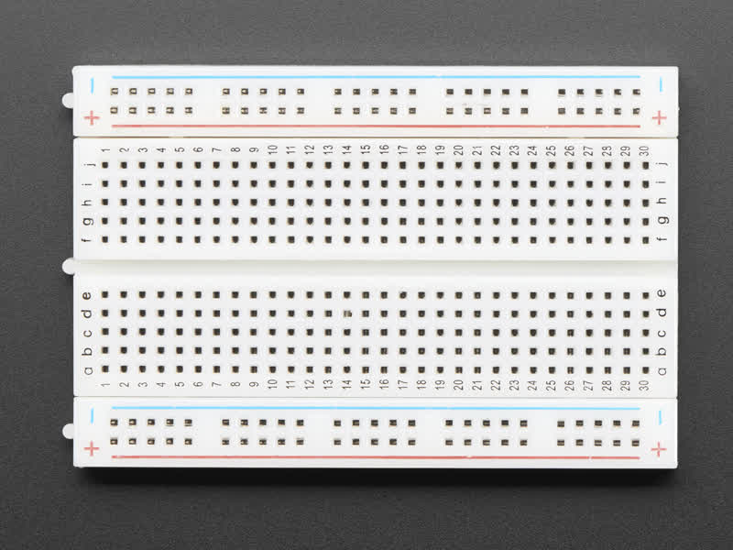
Fig-5
Jumper Wires
Jumper wires are used to establish electrical connections between components on the breadboard and the Arduino. Male-to-male jumper wires are used for breadboard connections, while male-to-female jumper wires are used to connect sensors and modules. These wires ensure flexible and reliable circuit connections.
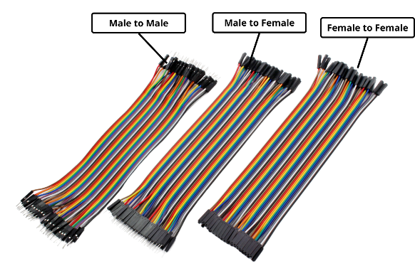
Fig-6
Android Smartphone:
An Android smartphone is used to run the mobile application developed using Python and the Kivy framework. The application receives pill status data via Bluetooth, displays alerts, and provides the medicine reordering feature.
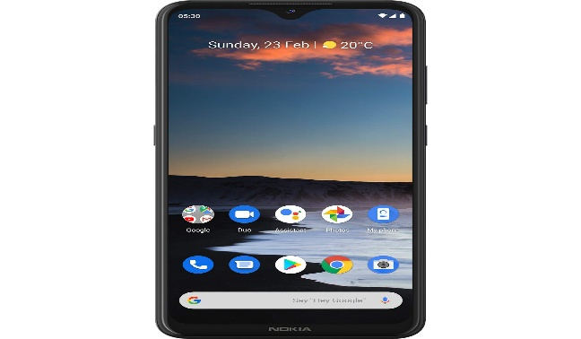
Fig-7

-5-
Power Supply:
A regulated power supply or USB power source is used to power the Arduino and connected components. Stable power ensures accurate sensor readings and reliable system operation.

3.3.2 System Diagram

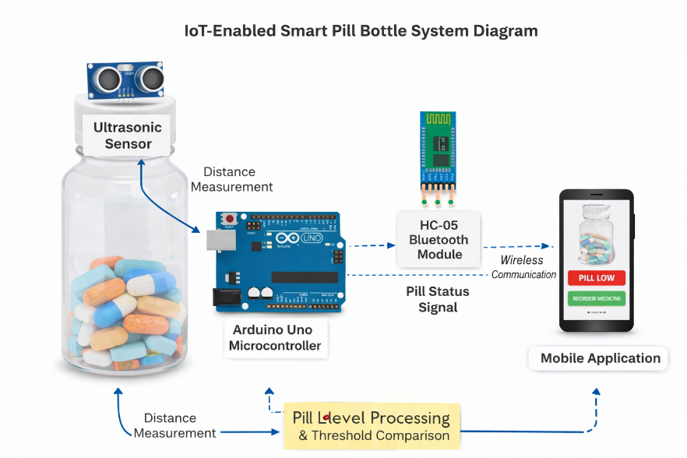
Fig-8
The system diagram illustrates the complete hardware architecture of the IoT-Enabled Smart Pill Bottle for Medicine Reordering. In this setup, an ultrasonic sensor (HC-SR04) is mounted on the cap of the pill bottle, facing downward to measure the distance between the sensor and the surface of the pills. This distance corresponds to the remaining pill quantity inside the bottle.
The ultrasonic sensor is connected to an Arduino Uno microcontroller using jumper wires through a breadboard, which is used for easy prototyping and power distribution. The Arduino acts as the central control unit of the system. It continuously reads distance values from the ultrasonic sensor, processes the data, and determines the pill status as full, partially filled, or empty based on predefined threshold values.
An HC-05 Bluetooth module is interfaced with the Arduino to enable wireless communication. Once the pill status is determined, the Arduino transmits this information to a mobile application via Bluetooth. The breadboard and jumper wires provide flexible and organized connections between all components without permanent soldering.
The mobile application receives the pill status in real time and displays it to the user. When a low-stock condition is detected, the application alerts the user and provides a medicine reordering option, allowing timely refilling. This system diagram demonstrates the seamless integration of sensors, embedded hardware, wireless communication, and a mobile interface to achieve efficient medication monitoring.

-6-
Chapter 4
Implementation

The implementation of the IoT-Enabled Smart Pill Bottle for Medicine Reordering consists of two main software components:

- Arduino Embedded Program

- Mobile Application Program

These two files work together to monitor pill levels and notify the user through a mobile application.

4.1 Arduino Program (Embedded System Code)
File Name: pill_monitor.ino
Description
This Arduino program is responsible for reading distance values from the ultrasonic sensor mounted on the pill bottle cap. The program calculates the pill level based on the measured distance and compares it with a predefined threshold value. If the pill level falls below the threshold, the system identifies a low-stock condition.
The Arduino communicates the pill status wirelessly to the mobile application using the HC-05 Bluetooth module. To avoid repeated alerts, the program sends data only when there is a change in pill status. This ensures stable operation and efficient communication.

Arduino Code:

#define TRIG 9
#define ECHO 10

long duration;
int distance;

const int THRESHOLD = 7; // cm
char lastState = 'X'; // Unknown at start

void setup() {
Serial.begin(9600);
pinMode(TRIG, OUTPUT);
pinMode(ECHO, INPUT);

Serial.println("Pill Monitor Started");
}
-7-
void loop() {

// Trigger ultrasonic pulse
digitalWrite(TRIG, LOW);
delayMicroseconds(2);
digitalWrite(TRIG, HIGH);
delayMicroseconds(10);
digitalWrite(TRIG, LOW);

// Read echo with timeout
duration = pulseIn(ECHO, HIGH, 30000);
if (duration == 0) return;

// Convert to distance (cm)
distance = duration * 0.034 / 2;

char currentState;

if (distance > THRESHOLD) {
currentState = 'L'; // Pill Low
} else {
currentState = 'S'; // Stock In
}

// Send ONLY when state changes
if (currentState != lastState) {

// Bluetooth data (DO NOT CHANGE)
Serial.write(currentState);
Serial.write('\n');

// Serial Monitor (for showcase)
if (currentState == 'L') {
Serial.println("PILL LOW");
} else {
Serial.println("STOCK IN");
}

lastState = currentState;
}

delay(300); // smooth updates
}

-8-

4.2 Mobile Application Program (Android App Code)

File Name: main.py, pillapp.kv

Description
The mobile application is developed using Python and the Kivy framework, which allows cross-platform mobile app development. The application establishes a Bluetooth connection with the HC-05 module connected to the Arduino. It continuously listens for incoming pill status messages.
When a low-stock message is received, the application displays an alert to the user and provides a medicine reorder button. This button redirects the user to a medicine ordering platform, enabling quick and convenient refilling of medicines. The application acts as the user interface of the system.

Mobile Application Code:
main.py
from kivy.app import App
from kivy.lang import Builder
from kivy.uix.boxlayout import BoxLayout
from kivy.clock import Clock
from threading import Thread
from jnius import autoclass
# Android permissions
from android.permissions import request_permissions, Permission
# ---- Bluetooth classes ----
BluetoothAdapter = autoclass('android.bluetooth.BluetoothAdapter')
UUID = autoclass('java.util.UUID')
# ---- HC-05 DETAILS ----
HC05_MAC = "00:00:13:03:8A:42"
SPP_UUID = UUID.fromString("00001101-0000-1000-8000-00805F9B34FB")
class MainLayout(BoxLayout):
socket = None
stream = None
def connect_bt(self):
self.ids.connection_status.text = "Connecting..."
Thread(target=self._connect_worker, daemon=True).start()
def _connect_worker(self):
try:
adapter = BluetoothAdapter.getDefaultAdapter()
-9-
if not adapter or not adapter.isEnabled():
self.ids.connection_status.text = "Bluetooth OFF"
return
device = adapter.getRemoteDevice(HC05_MAC)
socket = device.createRfcommSocketToServiceRecord(SPP_UUID)
adapter.cancelDiscovery() # VERY IMPORTANT
socket.connect() # MUST be background thread
self.socket = socket
self.stream = socket.getInputStream()
self.ids.connection_status.text = "Connected"
Clock.schedule_interval(self.read_data, 1)
except Exception as e:
self.ids.connection_status.text = "Connection Failed"
print("BT ERROR:", e)
def read_data(self, dt):
try:
if self.stream and self.stream.available() > 0:
data = self.stream.read()
msg = chr(data)
if msg == 'L':
self.ids.data_label.text = "Pill Low"
elif msg == 'S':
self.ids.data_label.text = "Stock In"
except Exception:
pass
def reorder_medicine(self):
import webbrowser
webbrowser.open("https://www.tata1mg.com")
class PillApp(App):
def build(self):
request_permissions([
Permission.BLUETOOTH_CONNECT,
Permission.BLUETOOTH_SCAN
])
return Builder.load_file("pillapp.kv")

-10-
if __name__ == “__main__”:
PillApp().run()

pillapp.kv

BoxLayout:
orientation: 'vertical'
padding: 20
spacing: 20
Label:
id: connection_status
text: "Not Connected"
font_size: 20
Label:
id: status_label
text: "Waiting for data"
font_size: 22
bold: True
Button:
text: "Connect Bluetooth"
size_hint_y: None
height: 50
on_press: app.connect_bt()
Button:
text: "Reorder Medicine"
size_hint_y: None
height: 50
on_press: app.reorder_medicine()

-11-
Chapter 5
Results and Analysis
User Testing & Feedback
Sample:
Participants included elderly users and caretakers.
Quantitative Results:
- Accurate detection of pill level changes
- Reliable Bluetooth communication
- Immediate low-stock alerts
Qualitative Feedback:
- Users found the system easy to use
- Reorder feature reduced refill delays
- System improved medication management confidence
For this hardware-based project, photographs of the hardware setup and screenshots of the mobile application were captured and analyzed. The results confirm that the project objectives were successfully achieved.

Hardware Setup and Output Description

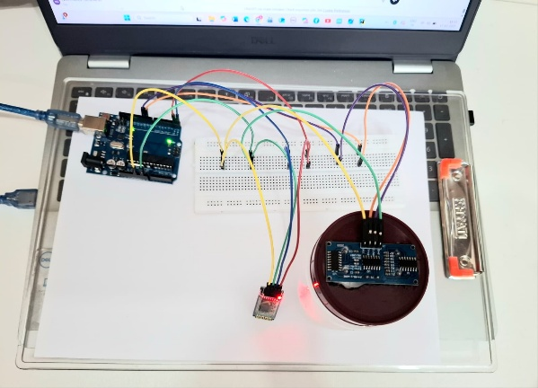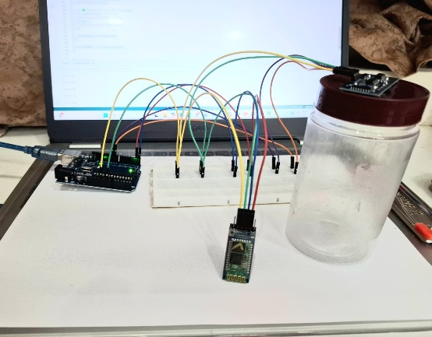

Fig-9
The photographs show the complete hardware setup of the IoT-Enabled Smart Pill Bottle for Medicine Reordering. An ultrasonic sensor mounted on the bottle cap measures the pill level, and the Arduino Uno processes this data to determine the bottle status. The HC-05 Bluetooth module transmits the pill status wirelessly to the mobile application. During testing, changes in pill quantity were accurately detected and successfully reflected in the application. The results confirm reliable sensor operation and stable Bluetooth communication.

-12-
Mobile Application:-

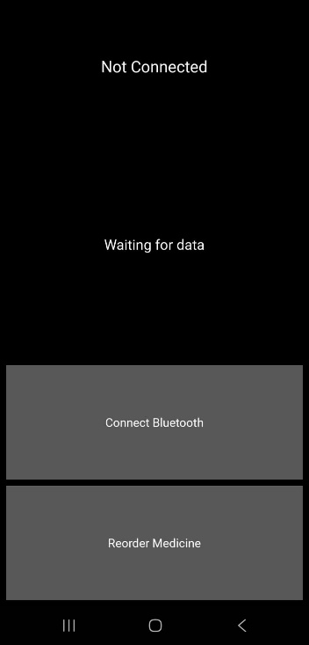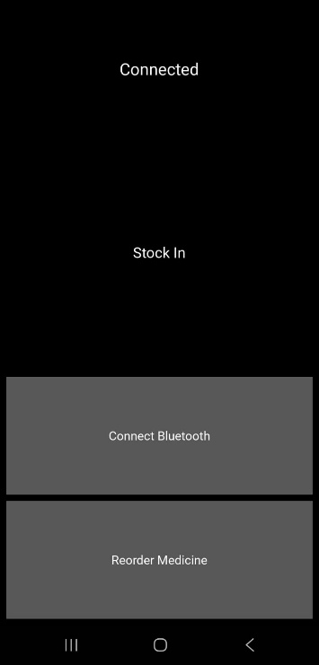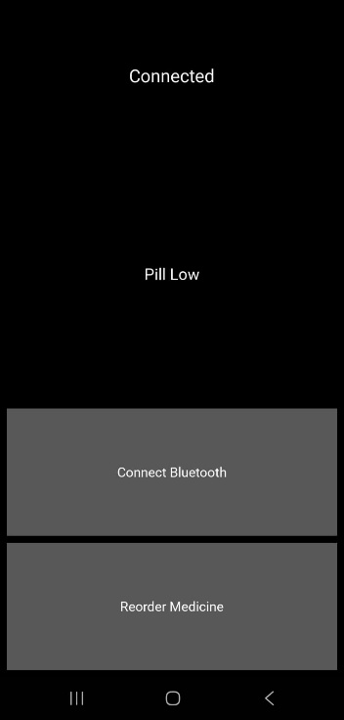
Figure(a) Figure(b) Figure(c)
Fig-10
Figure(a) - Not Connected / Waiting for Data
This screenshot represents the initial or disconnected state of the application. The message “Not Connected” indicates that the Bluetooth connection has not yet been established, and “Waiting for data” shows that the application is ready to receive pill status once the connection is made. This ensures clear user feedback regarding system status.

Figure(b) - Bluetooth Connected – Stock In Status
This screenshot shows the application in a connected state with the pill status displayed as “Stock In”. This indicates that sufficient pills are available inside the bottle. The result confirms accurate sensor measurement and correct data transmission from the hardware to the mobile application.

Figure© - Bluetooth Connected – Pill Low Status
This screenshot displays the mobile application when the Bluetooth connection with the smart pill bottle is successfully established. The status “Connected” confirms active communication with the Arduino system. The message “Pill Low” indicates that the ultrasonic sensor has detected a low medicine level inside the bottle, prompting the user to reorder medicines.

-13-
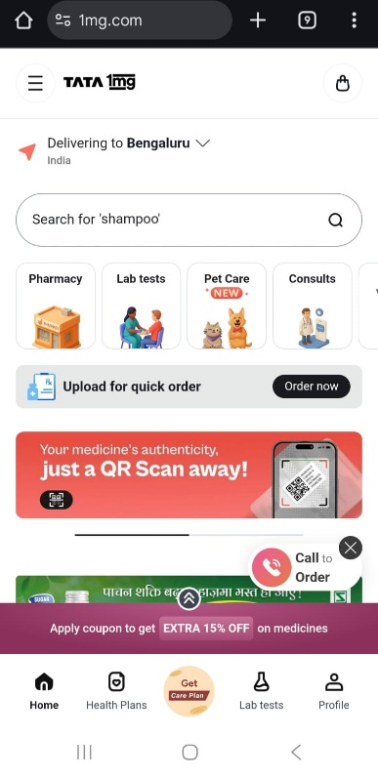

Figure(d)

Figure(d) – Online Pharmacy Interface (Reorder Page)
This screenshot shows the online pharmacy platform used for medicine reordering. When the user clicks the “Reorder Medicine” button in the mobile application, they are redirected to this page. It allows the user to search for medicines and place an order online, ensuring timely refilling when pill stock is low.

-14-
Chapter 6
Conclusion & Future Work
Conclusion & Future Work
The IoT-Enabled Smart Pill Bottle for Medicine Reordering successfully addresses the problem of manual pill stock monitoring. The system automates pill level detection, provides timely alerts, and simplifies the medicine reordering process. It is cost-effective, reliable, and suitable for real-world healthcare applications.
Future Work
- Cloud-based IoT integration
- Automatic online medicine ordering
- Medicine intake reminders

References
Research Papers
• R. K. Megalingam, R. N. Nair, and S. M. Prakhya: IoT Based Smart Medicine Reminder System, International Journal of Engineering Research & Technology (IJERT), 2020.
• P. S. Kumar, A. R. Reddy, and S. K. Rao: Design and Implementation of Smart Pill Dispenser Using IoT, International Journal of Computer Science and Network Security (IJCSNS), 2020.
• S. Patel and N. Shah: Smart Healthcare Monitoring System Using IoT, International Journal of Advanced Research in Computer Engineering & Technology, 2019.

Online articles
• https://paper.ijcsns.org/07_book/202007/20200719.pdf
• https://www.instructables.com/Arduino-Bluetooth-and-Ultrasonic-sensor-TUTORIAL/
• https://www.arduino.cc/en/Guide
• https://kivy.org/doc/stable/

-15-
Annexures

Annexure A – User Feedback Forms
User | Feedback
A Giridharan | The system accurately detects low pill levels and is easy to understand.
E Neelamegan | The reorder medicine option is helpful and convenient.
Kritheeka k | The application interface is simple and user-friendly.

Annexure B – Iteration Notes
- Iteration 1: Initial idea was manual pill checking; automation was added using ultrasonic sensor.
- Iteration 2: Bluetooth communication was implemented to send pill status to mobile app.
- Iteration 3: Medicine reorder button was added to improve usability.
- Iteration 4: Threshold logic was refined to avoid frequent status switching.

Annexure C – Team Roles
Name | Role
G NIVETHASREE | Hardware setup, Arduino programming, mobile app development, testing, and documentation
G ABHIRAM | Hardware setup, Arduino programming, mobile app development, testing, and documentation
G ABHISHEK | Hardware setup, Arduino programming, mobile app development, testing, and documentation

-16-

THANK YOU

